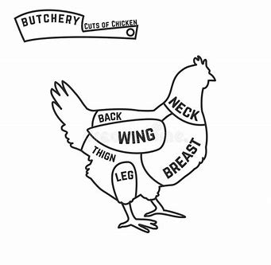
Menominee County Fair
Market Poultry Record Book

Please check age group of exhibitor:
_____ BEGINNER (8 – 11 YEARS)
_____ INTERMEDIATE (12 – 15 YEARS)
_____ ADVANCED (16 – 19 YEARS)
Official Fair Age ____ (Fair age is the exhibitors age on January 1 of the year of the fair)

Exhibitor Name: _______________________________________________
Address: _____________________________________________________
City, State, Zip: _______________________________________________
Birth Date: ______________________________
JUDGING RESULTS (OFFICE USE ONLY) RIBBON AWARD: 1 2 3
Club Name: ____________________________
Club Leader: ___________________________
Cell Phone Number ________________________

Market Poultry Projects (Please check the project you intend to complete. One record book per project):
Cornish Game “Hens”: ______
Up to 2 lbs. dressed weight (usually less than 5 weeks of age)
Broiler/Fryers: _________
2 ½ lbs. or more dressed weight (usually 6-10 weeks of age)
Roasters: _________
5 lbs. or more (usually 7 -12 weeks of age)

Leg Band Numbers: ________________________ Exhibitor I.D. #______________
(Leg bands and Exhibitor I.D. numbers issued on day of weigh in at the fair)
All Market Poultry Record Books are due by 12:00 P.M. Friday of the fair.
The record book needs to be completed by the exhibitor.
PLEASE TYPE, PRINT OR WRITE CLEARLY.
M.C.F. Poultry Record Book 1.
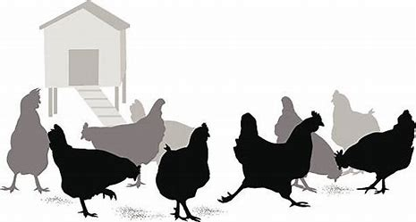
Menominee County Fair Market Poultry Rules:
(Please see the complete list of Poultry Dept. Rules in the Menominee County Fair premium book)
- Each exhibit shall consist of a “pen” of two (2) birds of either sex of any meat breed. (Birds must be the same breed, age, and weight).
- Exhibitors may enter a single exhibit (pen) in each of the three Poultry Market Classes.
- Pre-entry fee is $2.00 per Poultry Market Class.
- Each bird in an entry will be weighed in during the hours of placement. (Please see M.C.F. premium book for all entry dates and placement times).
- Each bird in an entry will be banded with a marked leg ban on the day of entry provided by the fair. (Please see M.C.F. premium book for all entry dates and placement times).
- Each bird will be health checked and examined for external parasites. Any birds that fail the health test will be sent home.
- The Poultry Superintendent, judge and Poultry Auction Superintendents have the right to disqualify a bird or birds that are sick, and that entry will be sent home.
- Each exhibitor will be required to complete a Youth Poultry Market Record Book for each entry (pen) in the poultry market classes.
- Completed Record books must be turned in by 12:00 P.M., Saturday of the fair.
- All Poultry Market exhibitors will be required to participate in poultry showmanship.
- Exhibitors will be allowed to bring their own feed or use the feed provided by the fair.
- Exhibitors are required to provide feed pans & water containers for their birds and clean their pens daily.
- Exhibitors in the Youth Poultry Market Class will be allowed to sell their birds in the Youth Poultry Market Auction starting at 12:00 P.M. on the Sunday of the fair.
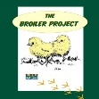
- Exhibitors wishing to learn more about raising meat breed chickens can access the “Broiler Project” pdf guide at:
https://www.lsuagcenter.com/articles/connected/the-broiler-project
Exhibitors will find the M.S.U. 4-H Poultry Fitting & Showmanship Member’s Guide pdf at:
https://www.canr.msu.edu/uploads/236/66874/4H1520_4-HPoultryFSMG.pdf
Please sign below to verify you have read and understand the above rules. Also note that any extra rules or rule changes will be provided to the exhibitor at the fair during check in. I understand that this is a completed Youth Poultry Market Record Book as required.
Youth Signature: __________________________________________________

Parent/Guardian Signature: __________________________________________ M.C.F. Poultry Record Book 2.
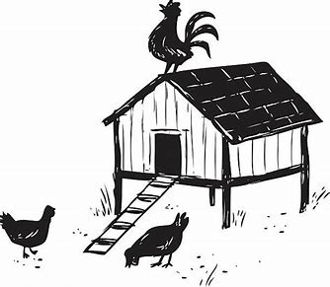
Market Poultry Project Photos
Be Creative! The more photographs the better! Your pictures should show the growth of your project from start to finish. Each picture needs to have a date, caption and be in chronological order. You may use additional pages.

M.C.F. Poultry Record Book 3.
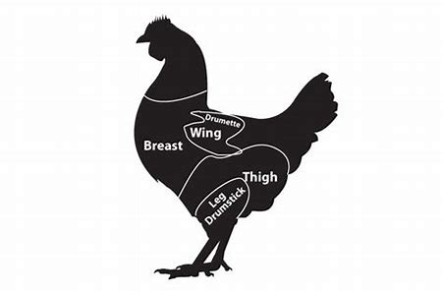
Poultry Project Goals (at start of your project)

State at least three goals at the beginning of your project. Explain what you would like to learn.
1.____________________________________________________ _____________________________________________________
_____________________________________________________

2._________________________________________________________________________________________________________
_____________________________________________________

3._________________________________________________________________________________________________________
_____________________________________________________
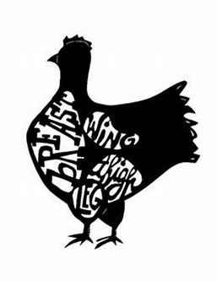
Poultry Project Accomplishments
(When project book is due)

What were the three most important things you learned this year about your Market Poultry Project? What goals have you accomplished? If you have not accomplished one or more of your goals, please explain. What have you learned? Describe your experiences this year. (Attach an additional page if needed.)
1._________________________________________________________________________________________________________

2._________________________________________________________________________________________________________

3. ____________________________________________________ ______________________________________________________

M.C.F. Poultry Record Book 4.
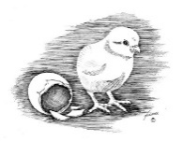
Day-Old Meat Breed Chicks Started

Date | Breed | Number Started | Number Raised
 | TOTAL

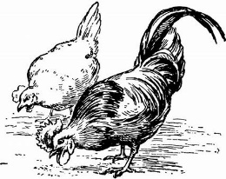
Did you buy straight run or pullet chicks? _____________________________________________________________ Feed Records Keeping good feed records is important. Good records show your expenses for feed and what kind of feed you use for your project. A good practice is to enter your feed expenses when you buy the feed. At the end of each month, total each kind of feed used and its cost and record the information below. Home-raised feeds should be valued at market prices (what it can be sold for) Additional pages can be used.

Date of  Purchase | Amount of  feed  purchased  (lbs.) | Type of feed | Cost or Value
 | Total  Pounds: | Total Feed Cost | $

M.C.F. Poultry Record Book 5.

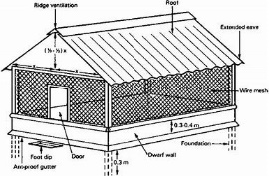
All Expenses Other Than Feed
(Equipment, Medications, Vet Expenses, etc.)
Enter here a record of all cash expenses for your poultry project. Record the date, the material and quantity as well as the cost. Also enter all non-cash expenses at their estimated value. (You may add extra sheets if necessary)

Date | Item or Material | Quantity | Cost or Value

TOTAL $

M.C.F. Poultry Record Book 6.

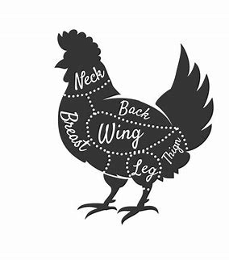
Poultry Market Weight Records
Please record the weights of each bird (in your pen of two) in the tables below. Use additional sheets if necessary.
First Bird of Pen - Date of Hatch: __________
Age of 1st Bird | Date of Weighing | Weight of 1st Bird | Weight Gain of 1st Bird
Second Bird of Pen - Date of Hatch: ___________
Age of 2nd Bird | Date of Weighing | Weight of 2nd Bird | Weight Gain of 2nd Bird
M.C.F. Poultry Record Book 7.

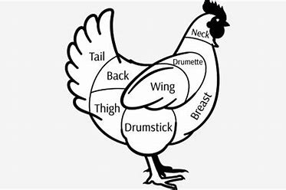
Poultry Project Expense Record

All expenses reflected here occurred from:
Start date of project: _________________________
End date of project: __________________________

Total Cost of Meat Breed Chicks: $___________________________________

Total Cost Feed for Project: $________________________________________
Total amount of feed fed to birds during project: _____________________lbs.
Cost of all supplies other than feed: $_________________________________

Cost of Poultry Equipment Used: $___________________________________

Vet care or general health expenses: $_________________________________

Mortality of chicks during project (Expense Loss): -$_____________________

Other Costs (Please specify): $________________________________________
A. TOTAL POULTRY PROJECT EXPENSES: $_________________

EXPECTED PROJECT INCOME: How much you expect to sell your pen of birds for at Menominee County Fair Auction: $________________________

Formula to calculate your Breakeven price:

$ ____________ _____________ = $ ___________________________
Total Poultry Pen of (2) birds’ final Breakeven price for pen of birds needed
Project Expenses weight (weighed at to cover expenses.
(Line A.) fair)

M.C.F. Poultry Record Book 8.

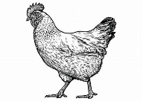
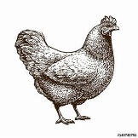
Your Poultry Project Story

Tell your poultry project story through your own words. It should cover why you selected the breed of birds and where you purchased your chicks/birds. You should also describe your daily care and feeding routine. It should also list any problems, if any, you had with your project. For example, if there is a drop in weight because your birds stopped eating. Explain what you did to get your birds well. The project story should be a summary of what you have learned from your market poultry experience. It might include interesting experiences, challenges, successes, and learning about the project overall. (Additional pages may be added)

___________________________________________________________________________________
___________________________________________________________________________________
___________________________________________________________________________________
___________________________________________________________________________________
___________________________________________________________________________________

General Poultry Management
Briefly Explain:
- What are the major external parasites “bugs” that poultry can have and how do you check for them?

- What are basic signs of good health in chickens?

M.C.F. Poultry Record Book Beginner 9.

PAGE | M.C.F. Market Poultry Judging Rubric | Possible Points | YOUR  POINTS
1 - 2 | Cover Sheet & Fair Rules | 5
 | All information is neat and complete
3 | Project Photos | 5
Includes photographs of project animal(s)
Captions included with pictures
4 | Project Goals & Accomplishments | 10
 | All information is neat and complete
5 | Starting Meat Chicks Table | 10
 | All information is neat and complete
5 | Feed Records | 10
 | All information is neat and complete
6 | All Expenses Other Thank Feed | 5
 | All information is neat and complete
7 | Poultry Market Weight Records | 15
 | All information is neat and complete
8 | Poultry Project Expense Record | 15
 | All information is neat & complete for class
9 | Project Story | 15
 | Story written
9 | General Poultry Management Questions | 10
 | All questions answered
 | TOTAL POINTS  1^{ST:} 100 – 80; 2ND : 79 – 60; 3RD : 59 - 30 | 100

M.C.F. Poultry Record Book 10.

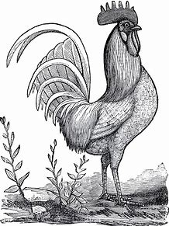JUDGES COMMENTS

